Brain Teasers
Q) Find the angle between hour and minute Oscillator at 3:15 am
7.5 degrees
Q) You have 9 balls, one has a weight different than the others. Find that ball in the least possible tries.
Take 6 balls, and weigh them. Take the lighter 3. Then take 2 out of those 3 and weigh them.
Q) You have a jar of 5 liters and a jar of 3 liters and have an unlimited water supply. Find a way to have 4 liters of water.
Fill the 3-liter tank. Put that water in the 5-liter tank. Again fill the 3-liter tank and put that water in the 5-liter tank. Empty the 5-liter tank and transfer the remaining 1 liter into the 5-liter tank. Then fill the 3-liter tank and transfer it to a 5-liter tank. You will have 4 liters of water in the 5-liter tank.

Programming Fundamentals
Q) Find the missing value in a series.
Since it is a series, the sum of the series is going to be n(n+1)/2, therefore take the sum and then subtract that from the sum of the series and you can find the sum of the series.
Another approach is to make an auxiliary count array, the element with count 0 will be the one
Another approach is to traverse the array, go to the index specified as the element and make it -1, the one with the positive number will be the one.
Q) Calculate the Fibonacci series
Q) How to check if a string is a palindrome or not
Q) Sum of individual numbers of an integer value, not an array
Q) Implement fibonacii series using recursion ?
Q) Find the maximum frequency for an element in Array using O(n) i.e. one loop only?
Q) Delete the element from nth index of an array?
Q) Print palindrome using recursion?
Q) Multiply two numbers without a multiplication operator?
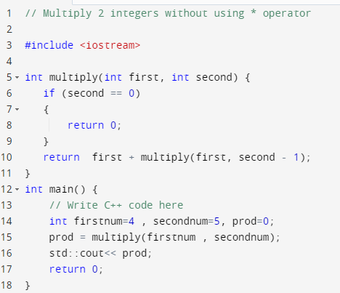
Q) Perform addition without using any arithmetic operator
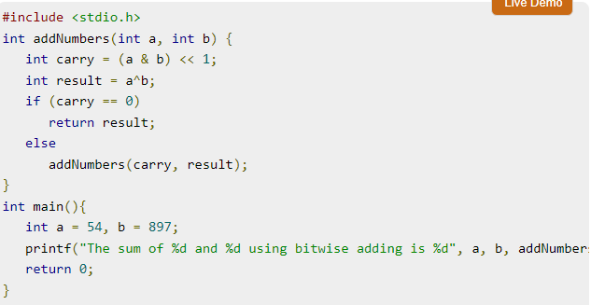
Q) Find even and odd without a modulus operator?
Three methods:
- Using Bitwise (&) operator
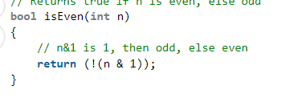
- Divide and multiply by 2
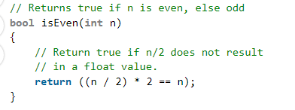
- Using loop and flag
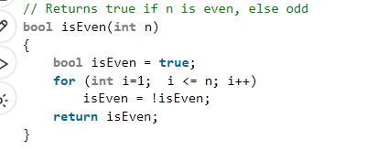
Q) Swap two numbers without using the third variable.
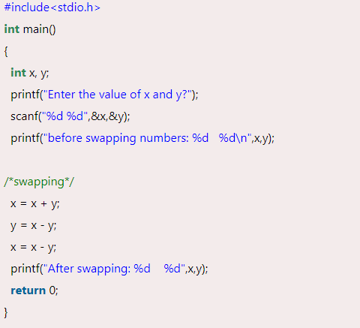
Q) Swap two strings without using the third variable.
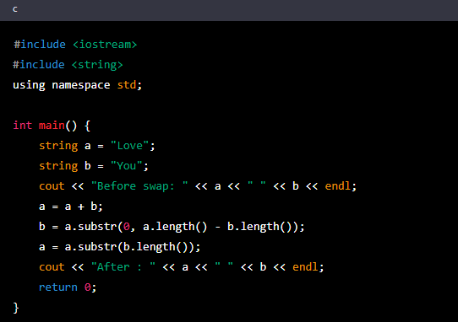

Object-Oriented Programming

Q) What are Upcasting and Downcasting?
Upcasting is the conversion of a derived class object to a base class object. It is also known as implicit casting or widening. In upcasting, the derived class object is treated as a base class object. Since the derived class inherits all the properties and methods of the base class, it is possible to perform this type of casting. Upcasting can be done automatically by the compiler, and it is always safe to perform.
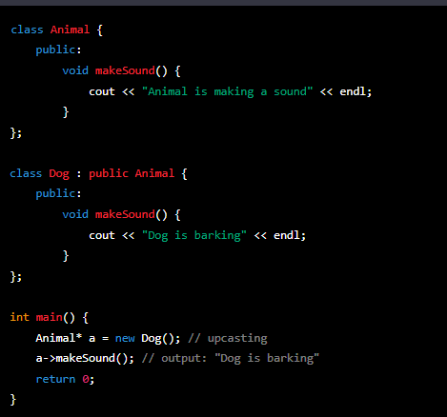
Downcasting, on the other hand, is the opposite of upcasting. It is the conversion of a base class object to a derived class object. It is also known as explicit casting or narrowing. In downcasting, the base class object is treated as a derived class object. Since the derived class may have additional properties and methods that are not present in the base class, downcasting is not always safe. It may result in a runtime error if the object being downcasted is not actually of the derived class type.
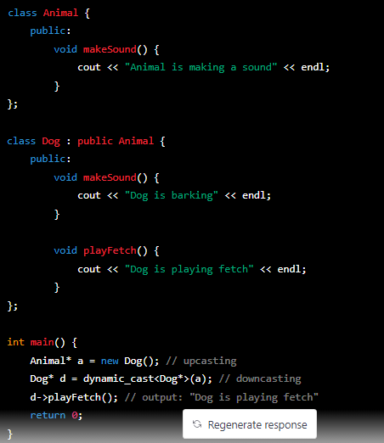

Q) What are Sealed classes and the difference between Sealed Class and Sealed Method?
A sealed class is a class that cannot be inherited or extended by any other class. It is a way of restricting the class hierarchy and preventing other classes from modifying or extending the behavior of the sealed class. In some programming languages, such as C#, a sealed class can still be instantiated and used like any other class, but it cannot be subclassed or derived from.
On the other hand, a sealed method is a method that cannot be overridden by any derived class. It is a way of restricting the behavior of a method in a derived class and ensuring that it behaves consistently across all subclasses. In some programming languages, such as C#, a sealed method must be marked with the sealed keyword in the base class, and it cannot be further overridden in any derived class.

Q) What is the difference b/w Struct and Class?
- Struct is stored in the stack, whereas Classes are stored in the heap.
- Structs are public by default whereas classes are private by default
- Structs do not contain methods where classes may or may not have methods
- In C#, structs do not have a default constructor.

Q: What are abstract classes? What are the distinct characteristics of an abstract class?
An abstract class is a class that cannot be instantiated and is always used as a base class. The following are the characteristics of an abstract class:
- You cannot instantiate an abstract class directly. This implies that you cannot create an object of the abstract class; it must be inherited.
- You can have abstract as well as non-abstract members in an abstract class.
- You must declare at least one abstract method in the abstract class.
- An abstract class is always public
- An abstract class is declared using the abstract keyword.
The basic purpose of an abstract class is to provide a common definition of the base class that multiple derived classes can share.

Q: Differentiate between an abstract class and an interface
An abstract class is a class that cannot be instantiated and is typically used as a base class for other classes. It may contain both abstract methods (methods without implementation) and concrete methods (methods with implementation). Abstract classes can have their own state, fields, and constructors. A class that inherits from an abstract class must implement all of the abstract methods defined in the base class.
An interface, on the other hand, is a contract that defines a set of methods that a class must implement. It cannot have any implementation of its own, and it cannot have any state. A class that implements an interface must provide an implementation for all of the methods defined in the interface.
In short, an abstract class is a class with some abstract methods and some implemented methods, whereas an interface is a contract that defines only abstract methods that a class must implement.

Q: What is the difference between Cohesion and Coupling?
Cohesion and coupling are two important concepts in software development that refer to the degree of interdependence between different components of a software system.
Cohesion refers to the degree to which the elements inside a module or component work together to achieve a single, well-defined purpose. High cohesion means that the elements inside a module or component are closely related and work together to achieve a specific goal, while low cohesion means that the elements inside a module or component are loosely related and may perform unrelated tasks. A highly cohesive module or component is considered to be well-structured and easy to understand and maintain.
Coupling, on the other hand, refers to the degree of interdependence between different modules or components. High coupling means that a change in one module or component will likely affect other modules or components, while low coupling means that a change in one module or component will have little or no effect on other modules or components. A system with low coupling is considered to be more flexible and easier to maintain and modify.
In summary, Cohesion is about how closely the responsibilities of a single module or component are related to each other, whereas Coupling is about how closely the responsibilities of different modules or components are related to each other.
Q: What is the difference between encapsulation and abstraction?
Encapsulation: Imagine a toy box. The toy box has many toys inside, but you can't see them because the box is closed and has a lid. You can only interact with the toys inside the box by using the handle on the lid. This is encapsulation in action: the toys inside the box are encapsulated, meaning they are protected and not directly accessible, and you interact with them through a simplified interface (the handle on the lid).
Abstraction: Imagine a remote control. The remote control has many buttons, but you only use a few of them to change channels on your TV. The other buttons do other things like adjusting the volume, but you don't need to know how they work to change channels. This is abstraction in action: the remote control has many features, but the interface is simplified and you only need to know the essential features (the buttons to change channels) to use it.
In simple words, Encapsulation is about hiding the implementation details and exposing a simplified public interface, whereas Abstraction is about simplifying the interface and hiding unnecessary details.
Q: What is the difference between shallow copy and deep copy with respect to copy constructors?
A shallow copy creates a new object that shares the same memory as the original object. In other words, the new object and the original object point to the same memory location. If the original object is modified, the new object will also be modified, because they both point to the same memory location.
A deep copy creates a new object that has its own copy of the data, separate from the original object. If the original object is modified, the new object will not be affected because they have their own separate copies of the data.
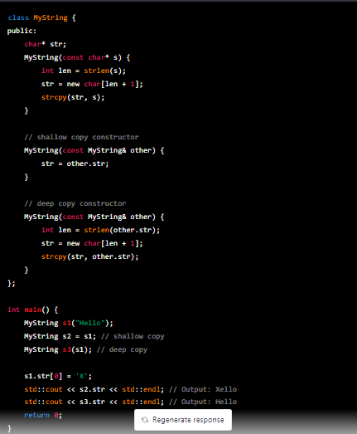
In this example, the class MyString has a pointer str that points to dynamically allocated memory. The class has two constructors, a shallow copy constructor and a deep copy constructor. The shallow copy constructor simply copies the pointer, while the deep copy constructor creates a new memory location and copies the data to it.
When we create a new object s2 and assign it the value of s1, it uses the shallow copy constructor, so both s1 and s2 point to the same memory location. If we change the value of s1, s2 will also be changed because they both point to the same memory location.
Q: What is a diamond problem and how can it be solved?
The diamond problem is a term used to describe an ambiguity that can arise in object-oriented programming when a class inherits from two or more classes that have a common base class. The problem occurs when a member of the common base class is accessed through an object of the derived class and it is unclear which version of the member should be accessed.
It can be solved by:
- Virtual Inheritance: In C++, when a class is inherited virtually, only one copy of the base class is shared among all the derived classes. This eliminates the ambiguity of the diamond problem by ensuring that there is only one version of the base class's members. To inherit a class virtually, use the keyword virtual before the base class in the derived class's definition.
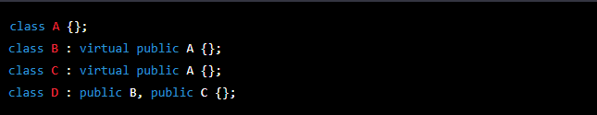
Q: What are virtual functions?
In this code, there are two classes Base and Derived. Base class has two functions, print() and show(). Derived class has also two functions, print() and show().
In the main function, a pointer of type Base is created and it's pointing to the object of the Derived class.
In the first statement, ptr->print() is called, as the function print() is virtual in the Base class, so the program will check the type of the object that the pointer is pointing to and it will call the appropriate function accordingly, so the function print() of Derived class is called and "Derived Class" is printed.
In the second statement, ptr->show() is called, as the function show() is not virtual in the Base class, so the program will not check the type of the object that the pointer is pointing to, it will always call the function show() of Base class, so "Show of Base Class" is printed.
The virtual keyword is used to indicate that a function can be overridden in derived classes. Without the virtual keyword, the function is considered non-virtual, and the program will always call the function of the type that the pointer is declared as, not the type of the object the pointer is pointing to.
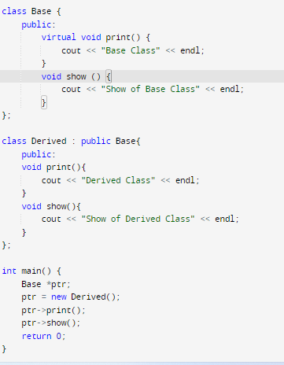
Q: What are pure virtual functions?
A pure virtual function is a virtual function that is declared in a base class but has no implementation. It is used to create an abstract class, which is a class that cannot be instantiated.
A pure virtual function is declared by placing the "= 0" at the end of its declaration.
class Shape {
public:
virtual double getArea() = 0;
};

In this example, the class Shape has a pure virtual function getArea(). This class cannot be instantiated because it has a pure virtual function that has no implementation.
Any class that inherits from an abstract class must provide an implementation for all of its pure virtual functions, otherwise, the derived class becomes an abstract class too.
Pure virtual functions are used to define an interface for a class, which specifies what methods a class must have without providing an implementation. This is useful when you want to create a class hierarchy, but you don't know what the specific implementation should be.
Q. When and why do we use static constructors?
A static constructor is used to initialize any static data, or to perform a particular action that needs to be performed only once.
Q) Can an object of a child type be assigned to a variable of the parent type? For example,
Card crd;
BirthDay bd = new BirthDay("Lucinda", 42);
crd = bd; // is this correct?
Yes—an object can be assigned to a reference variable of the parent type.
Q) You have written a class MyClass, which overrides a base class method void DoSomething(). Can you prevent the MyClass override DoSomething from being further overridden? If so, how?

a) Yes, declare the method as a sealed override in MyClass
b) Yes, declare the method as virtual sealed in MyClass
c) No, once a method has been overriden, preventing further overrides is not possible
d) Yes, declare the method as a private override in MyClass

a) Yes, declare the method as a sealed override in MyClass.
Declaring a method as "sealed" in a derived class prevents any further overriding of that method in any derived classes that inherit from it. Therefore, if you want to prevent further overriding of an overridden method, you can mark it as "sealed".
Q) What are SOLID principles?
Q) How many types of design patterns are there?
There are three main categories of design patterns: creational patterns, structural patterns, and behavioral patterns.
- Creational patterns: These patterns deal with object creation and are used to create objects in a way that promotes flexibility, reusability, and maintainability. Examples of creational patterns include Factory Method, Abstract Factory, Singleton, Builder, and Prototype.
- Structural patterns: These patterns deal with object composition and are used to create relationships between objects in a way that allows for flexible and efficient object interactions. Examples of structural patterns include Adapter, Bridge, Composite, Decorator, Facade, Flyweight, and Proxy.
- Behavioral patterns: These patterns deal with object interactions and are used to define the behavior of objects and the way they communicate with each other. Examples of behavioral patterns include Chain of Responsibility, Command, Interpreter, Iterator, Mediator, Memento, Observer, State, Strategy, Template Method, and Visitor.
Key Points:
- Friend function of a class is defined outside that class scope but has access to all the private and protected methods.
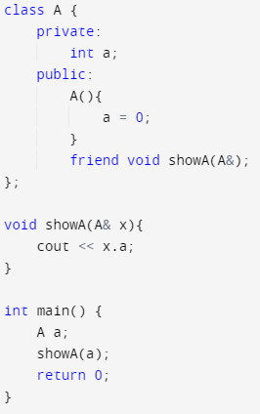
- A friend class can access private and protected members of other classes in which it is declared as a friend.
- Constant variables must be initialized when declared.
- Class object as const cannot call any non-const function, but can call const function
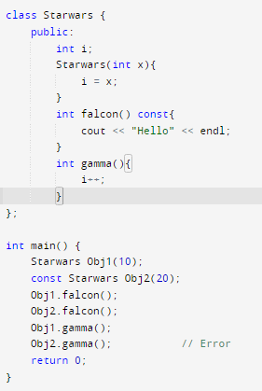
- Constructors have no return type
- Mutable is used with member variables of the class, which we want to change despite the object is const or the function is of const type
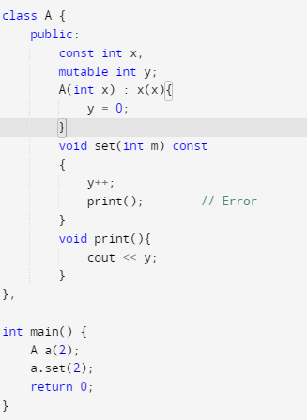
- Static members of the class are initialized outside the class, using the scope resolution :: operator.
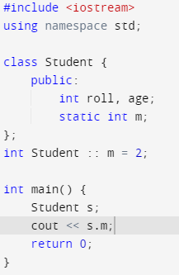
- A static member function can be called even if no object of the class exists and the static functions are accessed using only the class name and the scope resolution operator.
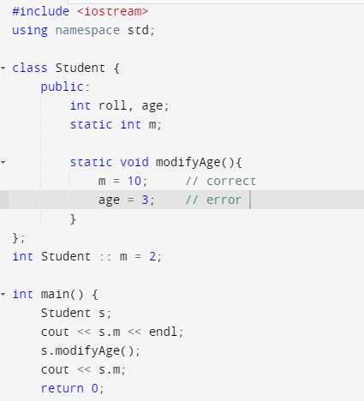
- A static member function can access only static data members, other static data member functions, and any other function from outside the class.
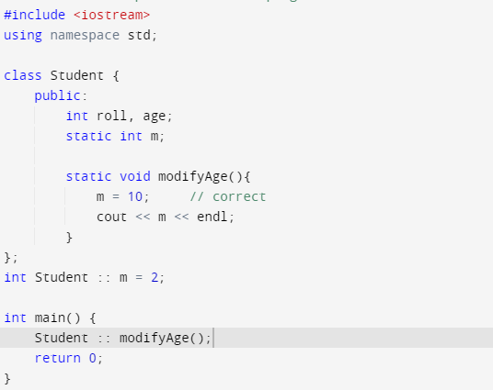
- Whenever the default constructor of the derived class is called, the default constructor of the base class is called automatically.
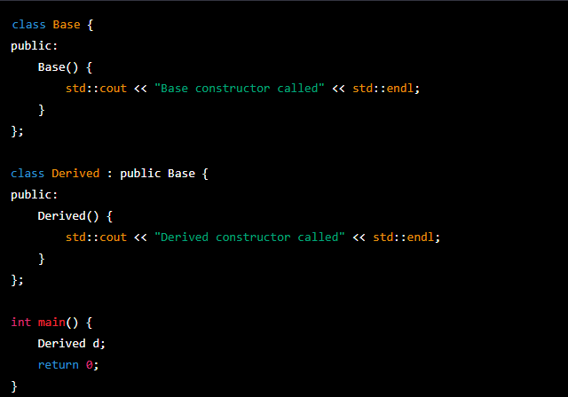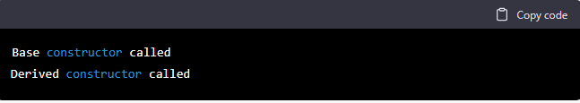
Data Structures
Q) What is the difference between List and Array?
Q) What is the difference between Array List and Array?
Q) What is the difference b/w Array List and Linked List?
Q) How to detect cycles in Linked List?
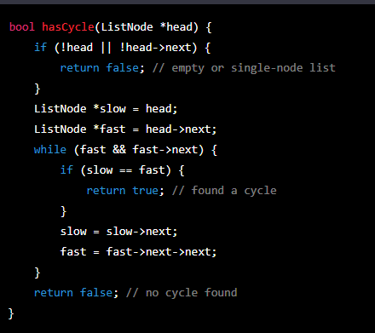
Q) What is Rule-Of-Three?
This rule basically states that if a class defines one (or more) of the following, it should explicitly define all three, which are:
- destructor
- copy constructor
- copy assignment operator
The Rule of Three is important because C++ has a default copy constructor, copy assignment operator, and a destructor that is automatically generated by the compiler. However, these default implementations may not work correctly for classes that manage dynamic memory or have other non-copyable resources.
When a class manages its own dynamic memory, the default copy constructor and copy assignment operator may cause a memory leak by creating multiple instances of the same object that point to the same memory. The default destructor may not properly release the memory, causing a memory leak.
When a class has other non-copyable resources such as file handles or network connections, the default copy constructor and copy assignment operator may cause conflicts by creating multiple instances that share the same resource.
Therefore, it is best practice to explicitly define all three (destructor, copy constructor, and copy assignment operator) when you define any of them, especially when the class manages its own dynamic memory or has other non-copyable resources. This way, you can ensure that the class's behavior is well-defined and that the resources are properly handled.
Key Points:
- Pre-Order traversal: (N, L, R)
- Post-Order traversal: (L, R, N)
- In-Order traversal: (L, N, R)
Practice Questions:
- How can you find the middle element of a singly linked list in one pass?
Using slow and fast pointer
- How would you implement a stack that also keeps track of the minimum element?
In this implementation, we use two stacks: data to store the elements pushed onto the stack, and mins to store the minimum elements seen so far. When we push an element onto the stack, we also check if it is smaller than or equal to the top element of mins (or if mins is empty), and push it onto mins if it is. When we pop an element from the stack, we also check if it is the same as the top element of mins, and pop it from mins if it is. The top method simply returns the top element of data, and the getMin method returns the top element of mins, which is the current minimum element in the stack.
- How would you implement a queue using two stacks?
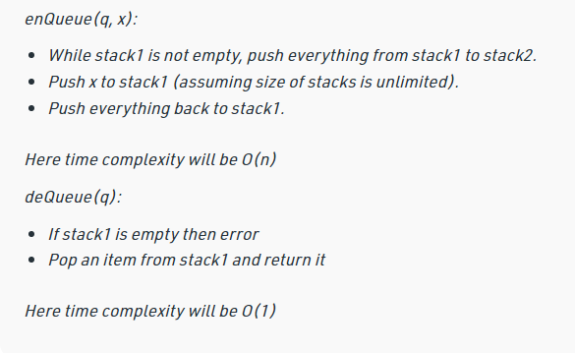
- How would you efficiently find the kth element from the end of a singly linked list?
Using slow and fast pointers. The fast pointer will take k steps, and once the fast pointer reaches the end of the linked list, the slow pointer will be at the kth position.
- How would you implement a binary search tree that allows for duplicate elements?

- How would you design a data structure that supports insertion, deletion, and finding the kth largest element in O(log n) time?
- How would you find the least common ancestor of two nodes in a binary tree?
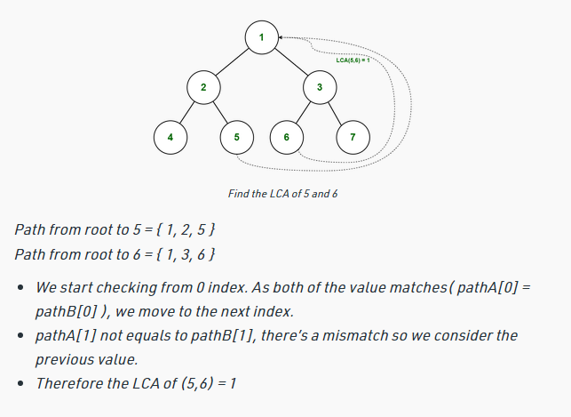
- How would you implement a Hash Table that can handle collisions?
- How would you reverse a singly linked list in place?
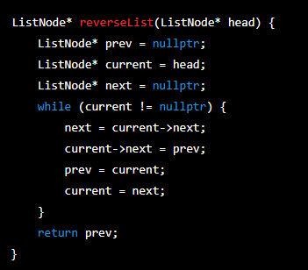
- How would you find the diameter of a binary tree in O(n) time?
- Calculate the height or depth of the binary tree.
- How to delete leaf nodes from the binary search tree?
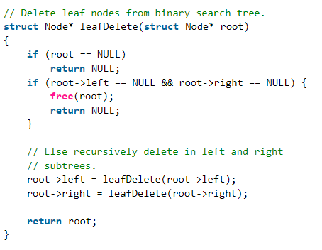
- Find sum of all left leaves in a given Binary Tree
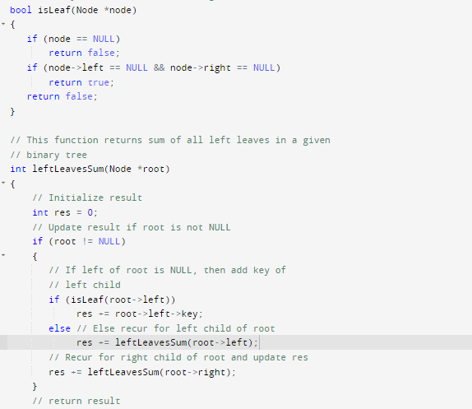

Database Management System
Q) What is indexing?
In database management systems, indexing is a technique for optimizing queries on large databases. Indexing is a way to organize the data in a database table so that it can be searched and retrieved more quickly.
An index in a database is a data structure that maps the values of one or more columns of a table to their physical locations on disk. When a query is executed against a table, the database can use the index to quickly locate the rows that match the query criteria.
For example, consider a table of customer records that contains millions of rows. Without an index, a query that searches for all customers with a particular last name would require scanning through every row in the table, which could take a long time. With an index on the last name column, the database can quickly locate the rows that match the search criteria and return the results much faster.
Indexes can be created on one or more columns of a table, and can be either unique or non-unique. Unique indexes ensure that each value in the indexed column is unique, while non-unique indexes allow duplicate values.
While indexing can improve the performance of database queries, it comes with some trade-offs. Indexes take up disk space and can slow down inserts, updates, and deletes on the table, as the index must be updated along with the table data. Therefore, it's important to carefully consider which columns to index and how many indexes to create, based on the specific needs of the application.
Q) What is one to one, one-to-many and many-to-many entity relationships and how to implement them?
Q) What are the types of indexing?
- B-tree index
- Clustered index
- Non-clustered index
- Hashmap index
- Bitmap index
- Spatial index
Q) What are the different Clauses used in SQL?
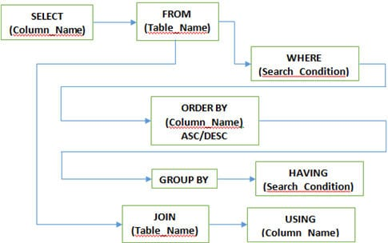
WHERE Clause: This clause is used to define the condition, and extract and display only those records which fulfill the given condition.
Syntax:
SELECT column_name(s)
FROM table_name
WHERE condition;
GROUP BY Clause: It is used with the SELECT statement to group the result of the executed query using the value specified in it. It matches the value with the column name in tables and groups the end result accordingly.
Syntax:
SELECT column_name(s)
FROM table_name
GROUP BY column_name;
HAVING clause: This clause is used in association with the GROUP BY clause. It is applied to each group of results or the entire result as a single group. It is much similar to the WHERE clause but the only difference is you cannot use it without the GROUP BY clause
Syntax:
SELECT column_name(s)
FROM table_name
GROUP BY column_name
HAVING condition;
ORDER BY clause: This clause is used to define the order of the query output either in ascending (ASC) or in descending (DESC). Ascending (ASC) is set as the default one but descending (DESC) is set explicitly.
Syntax:
SELECT column_name(s)
FROM table_name
WHERE condition
ORDER BY column_name ASC|DESC;
USING clause: USING clause comes in use while working with SQL JOIN. It is used to check equality based on columns when tables are joined. It can be used instead of the ON clause in JOIN.
Syntax:
SELECT column_name(s)
FROM table_name
JOIN table_name
USING (column_name);
Q) What are the types of joins?
Given below are the types of Join, which are explained with respect to the tables as an Example.
employee table:
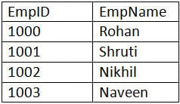
employee_info table:
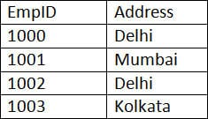
a) Inner JOIN: Inner JOIN is also known as a simple JOIN. This SQL query returns results from both the tables having a common value in rows.
SQL Query:
SELECT * from employee, employee_info WHERE employee.EmpID = employee_info.EmpID ;
Result:
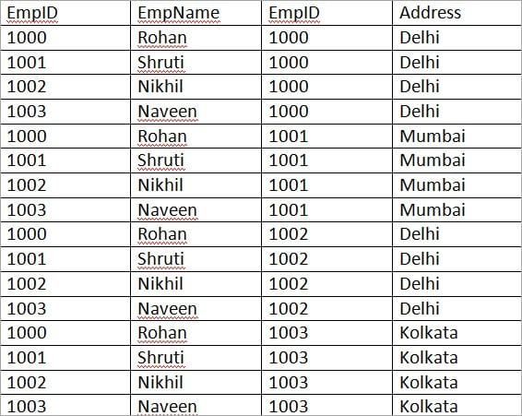
b) Natural JOIN: This is a type of Inner JOIN that returns results from both the tables having the same data values in the columns of both the tables to be joined.
SQL Query:
SELECT * from employee NATURAL JOIN employee_info;
Result:
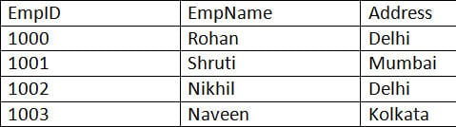
c) Cross JOIN: Cross JOIN returns the result as all the records where each row from the first table is combined with each row of the second table.
SQL Query:
SELECT * from employee CROSS JOIN employee_info;
Result:
Let us do some modification in the above tables to understand Right JOIN, Left JOIN, and Full JOIN.
employee table:
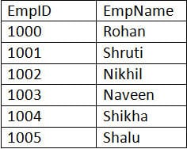
employee_info table:
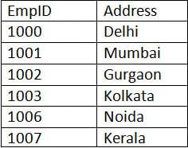
a) Right JOIN: Right JOIN is also known as Right Outer JOIN. This returns all the rows as a result from the right table even if the JOIN condition does not match any records in the left table.
SQL Query:
SELECT * from employee RIGHT OUTER JOIN employee_info on (employee.EmpID = employee_info.EmpID);
Result:
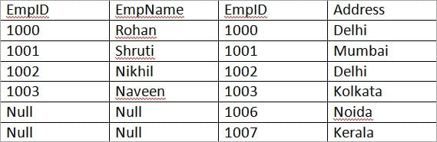
b) Left JOIN: Left JOIN is also known as Left Outer JOIN. This returns all the rows as a result of the left table even if the JOIN condition does not match any records in the right table. This is exactly the opposite of Right JOIN.
SQL Query:
SELECT * from employee LEFT OUTER JOIN employee_info on (employee.EmpID = employee_info.EmpID);
Result:
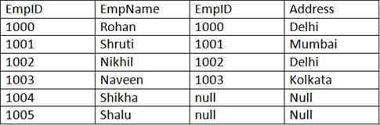
c) Outer/Full JOIN: Full JOIN return results in combining the result of both the Left JOIN and Right JOIN.
SQL Query:
SELECT * from employee FULL OUTER JOIN employee_info on (employee.EmpID = employee_info.EmpID);
Result:
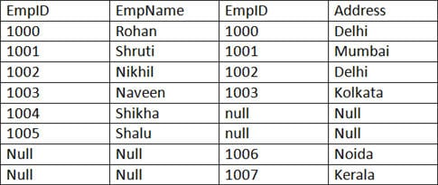
Q) When do we use self-join? Give some examples.
Self joins are used when you know that the key on which you have to map and the data you have to find exists in the same table with a condition of atleast or any number.
Examples:
- Find student id who is enrolled in atleast two course.
- Find customers that are from the same city
- Employee who is also the manager
Q) How many SQL statements are used? Define them.
SQL statements are basically divided into three categories, DDL, DML, and DCL.
- Data Definition Language (DDL) commands are used to define the structure that holds the data. These commands are auto-committed i.e. changes done by the DDL commands on the database are saved permanently.
  - CREATE to create a new table or database.
  - ALTER for alteration.
  - TRUNCATE to delete data from the table.
  - DROP to drop a table.
  - RENAME to rename a table.
- Data Manipulation Language (DML) commands are used to manipulate the data of the database. These commands are not auto-committed and can be rolled back.
  - INSERT to insert a new row.
  - UPDATE to update an existing row.
  - DELETE to delete a row.
  - MERGE for merging two rows or two tables.
- Data Control Language (DCL) commands are used to control the visibility of the data in the database like revoke access permission for using data in the database.
  - COMMIT to permanently save.
  - ROLLBACK to undo the change.
  - SAVEPOINT to save temporarily.
Q) Explain the terms ‘Record’, ‘Field’ and ‘Table’ in terms of database.
Record: A record is a collection of values or fields of a specific entity. For Example, An employee, Salary account, etc.
Field: A field refers to an area within a record that is reserved for specific data. For Example, Employee ID.
Table: The table is the collection of records of specific types. For Example, the Employee table is a collection of records related to all the employees.
Q) What do you understand by Data Independence? What are its two types?
Data Independence refers to the ability to modify the schema definition in one level in such a way that it does not affect the schema definition in the next higher level.
The 2 types of Data Independence are:
- Physical Data Independence: It modifies the schema at the physical level without affecting the schema at the conceptual level.
  - Example: if relocating the database from disk1 to disk2, it should not affect the database.
- Logical Data Independence: It modifies the schema at the conceptual level without affecting or causing changes in the schema at the view level.
  - Example: If entering a new column, it should not affect the actual structure. (Concept of views)
Q) What is meant by cascading? What happens when you say “on delete cascade”?
- When we do “on delete cascade”, all the foreign key in the referencing table are deleted of which we have deleted in the referenced table.
- It can also be used with on Update Cascade.
Q) What are the constraints in DBMS?
There are 5 types of constraints:
- Referential integrity constraint
  - Constraints between Referencing table and referenced table on Update, Delete, and Insert.
- Domain integrity constraint
  - The value of the attribute must be available in the corresponding domain
- Semantic integrity constraint
  - Salary of the employee should not exceed the salary of CEO
- Entity integrity constraint
  - Primary key value can’t be null
- Transactional constraint
  - Transition between one db state to another.
  - Example the salary of an employee can only increase not decrease.
Q) What do you understand by Functional dependency?
A relation is said to be in functional dependency when one attribute uniquely defines another attribute.
For Example, R is a Relation, X and Y are two attributes. T1 and T2 are two tuples. Then,
T1[X]=T2[X] and T1[Y]=T2[Y]
Means, the value of component X uniquely define the value of component Y.
Also, X->Y means Y is functionally dependent on X.
Q) What is the Database transaction?
Sequence of operation performed which changes the consistent state of the database to another is known as the database transaction. After the completion of the transaction, either the successful completion is reflected in the system or the transaction fails and no change is reflected.
There are 4 transaction controls such as
- COMMIT: It is used to save all changes made through the transaction.
- ROLLBACK: It is used to roll back the transaction. All changes made by the transaction are reverted back and the database remains as before.
- SET TRANSACTION: Set the name of the transaction.
- SAVEPOINT: It is used to set the point where the transaction is to be rolled back.
Q) What are triggers?
Triggers in SQL is kind of stored procedures used to create a response to a specific action performed on the table such as INSERT, UPDATE or DELETE. You can invoke triggers explicitly on the table in the database.
Action and Event are two main components of SQL triggers. When certain actions are performed, the event occurs in response to that action.
Syntax:
CREATE TRIGGER name {BEFORE|AFTER} (event [OR..]}
ON table_name [FOR [EACH] {ROW|STATEMENT}]
EXECUTE PROCEDURE functionname {arguments}
Q) How many row comparison operators are used while working with a subquery?
There are 3-row comparison operators that are used in subqueries such as IN, ANY, and ALL.
Q) Differentiate between ‘Cluster’ and ‘Non-cluster’ index.
Clustered index alters the table and re-order the way in which the records are stored in the table. Data retrieval is made faster by using the clustered index.
A Non-clustered index does alter the records that are stored in the table but creates a completely different object within the table.
Q) What do you understand by ‘Atomicity’ and ‘Aggregation’?
Atomicity is the condition where either all the actions of the transaction are performed or none. This means, when there is an incomplete transaction, the database management system itself will undo the effects done by the incomplete transaction.
Aggregation is the concept of expressing the relationship with the collection of entities and their relationships.
Q) Define checkpoint.
Checkpoint declares a point before which all the logs are stored permanently in the storage disk and is the inconsistent state. In the case of crashes, the amount of work and time is saved as the system can restart from the checkpoint.
Q) Define Stored procedures.
A Stored procedure is a collection of pre-compiled SQL Queries, which when executed denotes a program taking input, process and gives the output.
Syntax:
CREATE Procedure Procedure_Name
(
//Parameters
)
AS
BEGIN
SQL statements in stored procedures to update/retrieve records
END
Q) Differentiate between ‘DELETE’, ‘TRUNCATE’, and ‘DROP’ commands.
After the execution of ‘DELETE’ operation, COMMIT and ROLLBACK statements can be performed to retrieve the lost data.
After the execution of ‘TRUNCATE’ operation, COMMIT, and ROLLBACK statements cannot be performed to retrieve the lost data.
‘DROP’ command is used to drop the table or key like the primary key/foreign key.
Q) What is the difference between DELETE and TRUNCATE?
The differences are:
- DELETE commands deletes the table where as TRUNCATE only deletes the data inside that table.
- The basic difference in both is DELETE command is the DML command and the TRUNCATE command is DDL.
- DELETE command is used to delete a specific row from the table whereas the TRUNCATE command is used to remove all rows from the table.
- We can use the DELETE command with the WHERE clause but cannot use the TRUNCATE command with it.
Q) Select the correct result generated by execution of the following SQL statements:

CREATE TABLE HELO (ID INT, MESSAGE VARCHAR(255), LOGTIME TIMESTAMP);
CREATE TABLE HELO_01 () INHERITS (HELO);
INSERT INTO HELO_01 VALUES (1, 'ERROR' , CURRENT_TIMESTAMP);
SELECT * FROM HELO;
a) SELECT statement returns 1 rows, and exists successfully.
b) SELECT statement returns 0 rows, and exists successfully.
c) INSERT statement generates and error stating that the number of columns and values do not match
d) First 'CREATE_TABLE' generates a syntax error

The correct result generated by the execution of the given SQL statements is:
a) SELECT statement returns 1 row, and exits successfully.
Explanation:
The first SQL statement creates a table named "HELO" with three columns "ID", "MESSAGE", and "LOGTIME".
The second SQL statement creates a child table "HELO_01" that inherits all the columns from the "HELO" table.
The third SQL statement inserts a row into the "HELO_01" table with the values 1, 'ERROR', and the current timestamp.
Finally, the fourth SQL statement selects all rows from the "HELO" table, which includes the row inserted in the "HELO_01" table due to inheritance. Thus, the SELECT statement returns 1 row, and exists successfully.
Q) What is the difference between group by and distinct keywords?
Both GROUP BY and DISTINCT are used in SQL to retrieve unique values from a table, but there are some differences between them:
- DISTINCT: The DISTINCT keyword is used to retrieve distinct or unique values from a single column or set of columns in a table. It eliminates duplicate rows from the result set and returns only unique values.
- GROUP BY: The GROUP BY clause is used to group the result set by one or more columns and apply an aggregate function to each group. It is typically used with aggregate functions such as COUNT, SUM, AVG, MAX, or MIN to summarize the data.
In summary, DISTINCT is used to retrieve unique values from a single column or set of columns, while GROUP BY is used to group the result set by one or more columns and apply an aggregate function to each group
In this case, both will do the same.
SELECT FIRST_NAME FROM CUSTOMERS GROUP BY FIRST_NAME;
SELECT DISTINCT FIRST_NAME FROM CUSTOMERS;
Q) Discuss Normalization in DBMS
1 NF: Each column in the table should contain only one value and should not contain repeating groups.
2 NF: each column in the table should depend only on the primary key, and not on any other non-key attribute
3 NF: there should be no transitive dependencies between non-key attributes.
BCNF: each non-trivial functional dependency of a table must be a dependency on a candidate key. A candidate key is a combination of columns that uniquely identifies each row in the table.
For a table to be in BCNF, it must meet the following conditions:
- It must be in 3NF.
- For every non-trivial functional dependency (X → Y) in the table, X must be a superkey.
Q) What are ACID Properties?
Atomicity: Either all or none. (If any error in middle of transaction ,whole transaction will be rollbacked)
Consistency: Before and after state should justify.
Isolation: Multiple transactions can be executed concurrently without interfering with each other
Durability: All the changes should be permanent.
Queries:
- Find second max salary of employee.
SELECT MAX(SALARY) FROM EMPLOYEE
WHERE SALARY <>
(SELECT SALARY FROM EMPLOYEE
ORDER BY SALARY DESC
LIMIT 1)
OR (IN ORACLE MYSQL)
SELECT MAX(SALARY) FROM CUSTOMERS
WHERE SALARY
NOT IN (SELECT SALARY
FROM (SELECT SALARY FROM CUSTOMERS
ORDER BY SALARY DESC)
WHERE ROWNUM <= 3);.
Algorithms
Q) Practice of finding complexities in loop scenarios
Algorithm | Time Complexity |  |  | Space Complexity
 | Best | Average | Worst | Worst
Selection Sort | Ω(n^2) | θ(n^2) | O(n^2) | O(1)
Bubble Sort | Ω(n) | θ(n^2) | O(n^2) | O(1)
Insertion Sort | Ω(n) | θ(n^2) | O(n^2) | O(1)
Heap Sort | Ω(n log(n)) | θ(n log(n)) | O(n log(n)) | O(1)
Quick Sort | Ω(n log(n)) | θ(n log(n)) | O(n^2) | O(n)
Merge Sort | Ω(n log(n)) | θ(n log(n)) | O(n log(n)) | O(n)
Radix Sort | Ω(nk) | θ(nk) | O(nk) | O(n + k)
Count Sort | Ω(n +k) | θ(n +k) | O(n +k) | O(k)
Q) What is Master Theorem? How to find recurrence relations using Master Theorem?
Q) What is the difference between a recursive and iterative algorithm?
A recursive algorithm is one that calls itself to solve a problem, while an iterative algorithm uses loops to repeat a set of instructions. Recursion often results in cleaner and more concise code, but may be less efficient in terms of time and memory usage compared to iteration.
Q) What is dynamic programming? Provide an example of a problem that can be solved using dynamic programming.
Dynamic programming is a technique for solving problems by breaking them down into smaller subproblems and reusing solutions to those subproblems to solve the larger problem. An example problem that can be solved using dynamic programming is the Fibonacci sequence.
Q) Explain the difference between a greedy algorithm and a dynamic programming algorithm.
Greedy algorithms make the locally optimal choice at each step in order to find the overall optimal solution, while dynamic programming algorithms break down a problem into smaller subproblems and solve each subproblem once, storing the solutions in a table to be used later. The advantage of dynamic programming over greedy algorithms is that it can often find globally optimal solutions.
Q) What is the difference between breadth-first search and depth-first search algorithms? Provide an example of a problem that can be solved using each.
Breadth-first search (BFS) is a graph traversal algorithm that visits all the nodes at the same level before moving on to the next level, while depth-first search (DFS) visits all the nodes in a path before backtracking to explore other paths. An example problem that can be solved using BFS is finding the shortest path between two nodes in a graph, while DFS can be used to generate a maze.
Operating System
Q) What is the difference between processes and threads?
Q) What are locks?
Q) What is multi-threading?
Note: Revise OS algorithms like FCFS, Round Robin etc.

